Sakti Mujahid Imani
Jakarta, Indonesia | +6287754760524 | saktimujahid.9b@gmail.com | linkedin.com/in/saktimujahid
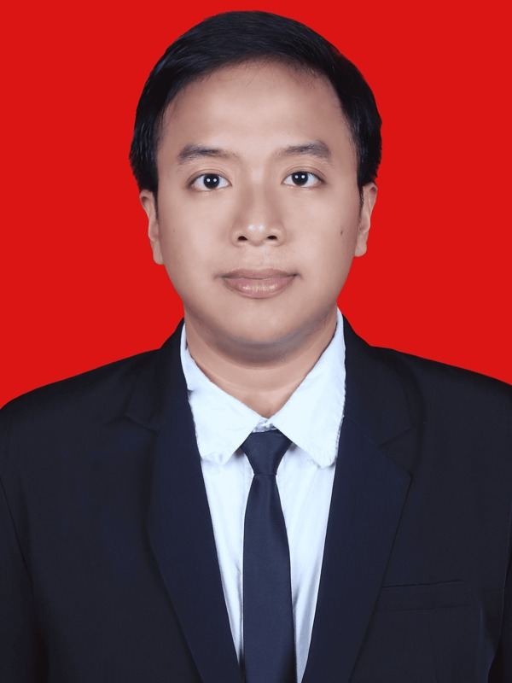 | Fresh Informatics Engineering graduate from Institut Teknologi Sumatera with hands-on experience in full-stack web development, data processing, machine learning, and project coordination. Built React, Laravel, and MySQL systems for campus and government workflows, including digital correspondence, inter-agency letter validation, and internship registration. Accustomed to translating user needs into clear features, managing Kanban-based tasks, documenting system flows, and validating releases through black-box testing and UAT. Interested in software engineering, data, and technology roles that value structured execution, clear communication, and fast learning.
EDUCATION
Institut Teknologi Sumatera - South Lampung, Indonesia Aug 2022 - 2026
Bachelor of Informatics Engineering, GPA: 3.56/4.00
- Thesis: "Development of the Student Affairs Subsystem for FTI ITERA Harmony Web Using Rational Unified Process (RUP) Method and Kanban Tools."
- Repository: repo.itera.ac.id/depan/submission/SB2606220028
WORK EXPERIENCE
Faculty of Industrial Technology, ITERA - South Lampung, Indonesia 2025 - 2026
Full Stack Developer, Website Harmony FTI (Independent Study / MBKM)
- Developed a student-affairs correspondence subsystem using React, Laravel, and MySQL; organized delivery through RUP phases and Kanban task tracking.
- Reduced campus letter-processing time from 7-10 to 2-5 working days, achieved 100% black-box test pass rate, and reached an 88.57% UAT score.
- Documented requirements, workflows, testing results, and user guidance to support handover between student developers, faculty stakeholders, and end users.
Dinas Kominfo Kota Bandar Lampung - Bandar Lampung, Indonesia 2025
Web Developer & Staff, Information Security and Cyber Division (Internship / MBKM)
- Contributed to SIMAS and SIMAMANG, government web systems for inter-agency letter validation, centralized recap, and online internship registration.
- Implemented account creation, document upload, application-status tracking, and multi-tenant data organization using Laravel, Inertia.js, React.js, and MySQL.
- Coordinated with supervisors to clarify requirements, report progress, and align feature delivery with institutional administrative workflows.
Institut Teknologi Sumatera - South Lampung, Indonesia 2023 - 2025
Teaching & Laboratory Assistant / Assistant Coordinator
- Handled assistant and coordinator assignments across 10+ courses/practicums, including Basic Physics, Introduction to Computer and Software, Software Engineering Fundamentals, and Formal Languages and Automata.
- Managed schedules, task allocation, grade recaps, student evaluation, and academic documentation with lecturers, laboratory staff, and assistant teams.
DBS Foundation x Dicoding - Indonesia 2025
Machine Learning Engineer Cohort, Coding Camp 2025 (Independent Study / MBKM)
- Completed structured training in Python, data analysis, machine learning, deep learning fundamentals, MLOps, and project-based model evaluation.
- Built CashEye, an accessibility-oriented computer vision application that detects Indonesian Rupiah denominations from images and returns audio feedback.
SELECTED PROJECTS
Web Harmony - Campus Correspondence System React, Laravel, MySQL
- Built student-affairs letter administration workflows; impact: 7-10 days reduced to 2-5 days with 100% black-box testing and 88.57% UAT; harmony.fti.itera.ac.id
SIMAS and SIMAMANG - Government Digital Systems Laravel, Inertia.js, React.js
- Supported letter-validation and internship-registration modules covering multi-tenant records, document upload, status tracking, and centralized reporting; SIMAS / SIMAMANG
End-to-End ETL Pipeline Python, Pytest, PostgreSQL
- Extracted product data from 50 pages, transformed it, and loaded outputs into CSV, Google Sheets API, and PostgreSQL with Pytest-based validation; GitHub repository
"Access by KAI" Sentiment Analysis Python, TF-IDF, XGBoost
- Scraped and cleaned Google Play reviews, trained Logistic Regression, XGBoost, and Naive Bayes models, and achieved the best result with XGBoost at 97% accuracy; GitHub repository
Afenter_PCD - Motorcycle Parking Area Detection Python, Streamlit, OpenCV
- Built an 11-stage image-processing pipeline for parking-slot segmentation and occupancy analysis from uploaded images; afenter.streamlit.app
Kyuubi-MML - Multimodal Music Emotion Recognition PyTorch, DeBERTa, PANN
- Classified music emotion using late fusion across audio, lyrics, and MIDI modalities with model documentation and experiment tracking; GitHub repository
Book Recommendation and Insurance Prediction Models Python, Scikit-learn
- Compared TF-IDF content-based filtering with collaborative filtering on a 1M+ row Book-Crossing dataset; improved Precision@5 from 0.04 to 0.42, and compared regression models for medical-cost prediction.
ORGANIZATIONAL AND LEADERSHIP EXPERIENCE
Informatics Student Association (HMIF) ITERA - South Lampung, Indonesia 2024 - 2025
Expert Staff, Member Development Division / Professional Training Staff / MBKM Sharing Session Speaker
- Supported student-development initiatives, professional-training programs, member communication, and event execution within the Informatics student community.
- Delivered an MBKM sharing session for Informatics students and helped prepare materials, documentation, and coordination flow for student-facing activities.
TRAINING AND CERTIFICATIONS
- Certification evidence: Google Drive certificates folder
- 2026: Prompt Engineering for Software Developers; Building Machine Learning Systems; Applied Data Science with Microsoft Fabric; Generative AI on Microsoft Azure; Practical AI for Productivity; MLOps.
- 2025: Applied Machine Learning; Machine Learning Development; Data Processing Fundamentals; Python Data Analysis; SQL Fundamentals; Git and GitHub; JavaScript Fundamentals; SOLID Principles; RevoU Intro to Data Analytics; DFIR Foundations.
- 2024: Project Management Fundamentals; Beginner Back-End Development with JavaScript; Java, C, and AWS Cloud Practitioner Essentials.
SKILLS AND ACHIEVEMENTS
- Technical Skills: React.js | Laravel | Inertia.js | MySQL | REST APIs | JavaScript | PHP | Python | Pandas | Scikit-learn | TensorFlow | PyTorch | OpenCV | Streamlit | Git/GitHub | Docker | GitHub Actions | MLflow
- Engineering Practices: RUP | Kanban | requirements gathering | technical documentation | black-box testing | UAT support | Pytest | data cleaning | model evaluation | stakeholder communication | progress reporting
- Achievements: Cum Laude graduate from ITERA (2026) | PHMW 2024 research and entrepreneurship grant recipient for "Burger with Ramen Noodle Bun" | 30+ technology and professional certifications.
- Languages: Indonesian (native) | English (limited working proficiency).

